**Citi Bike Analysis**

The following report includes analysis of the Citi Bike Trips from January and July 2020. This specific period of time was chosen to enable unbiased comparison of users behaviour during winter and summer time.

As seen in the Figure 1 the most common station for both starting and ending the trip in January was Grove St Path. Other popular stations were Harborside, Marin Light Rail and Sip Ave. The highest traffic can be observed within the stations in near to the underground entrance.

Similar pattern could be observed in July and overall increased traffic across all of the stations (Figure 2).

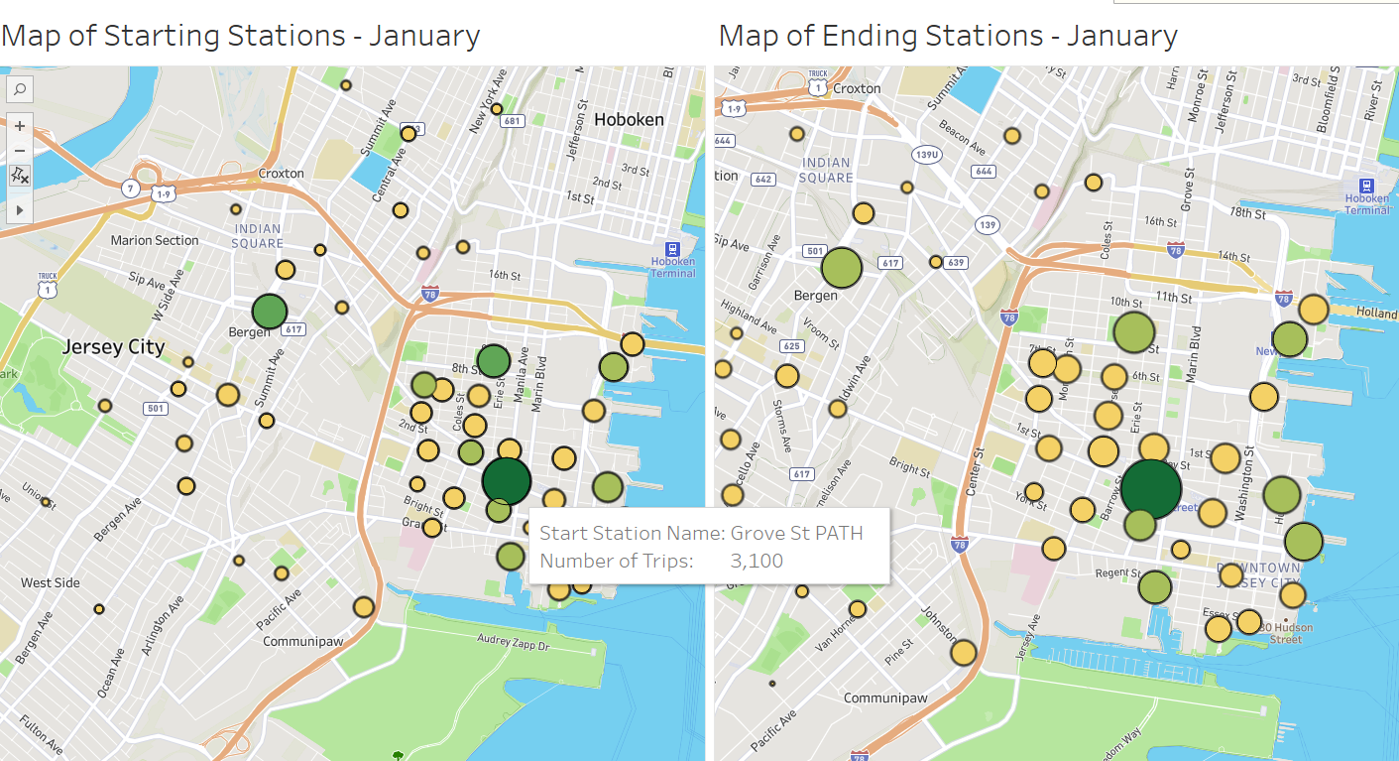

Figure 1. Popularity of Stations in January

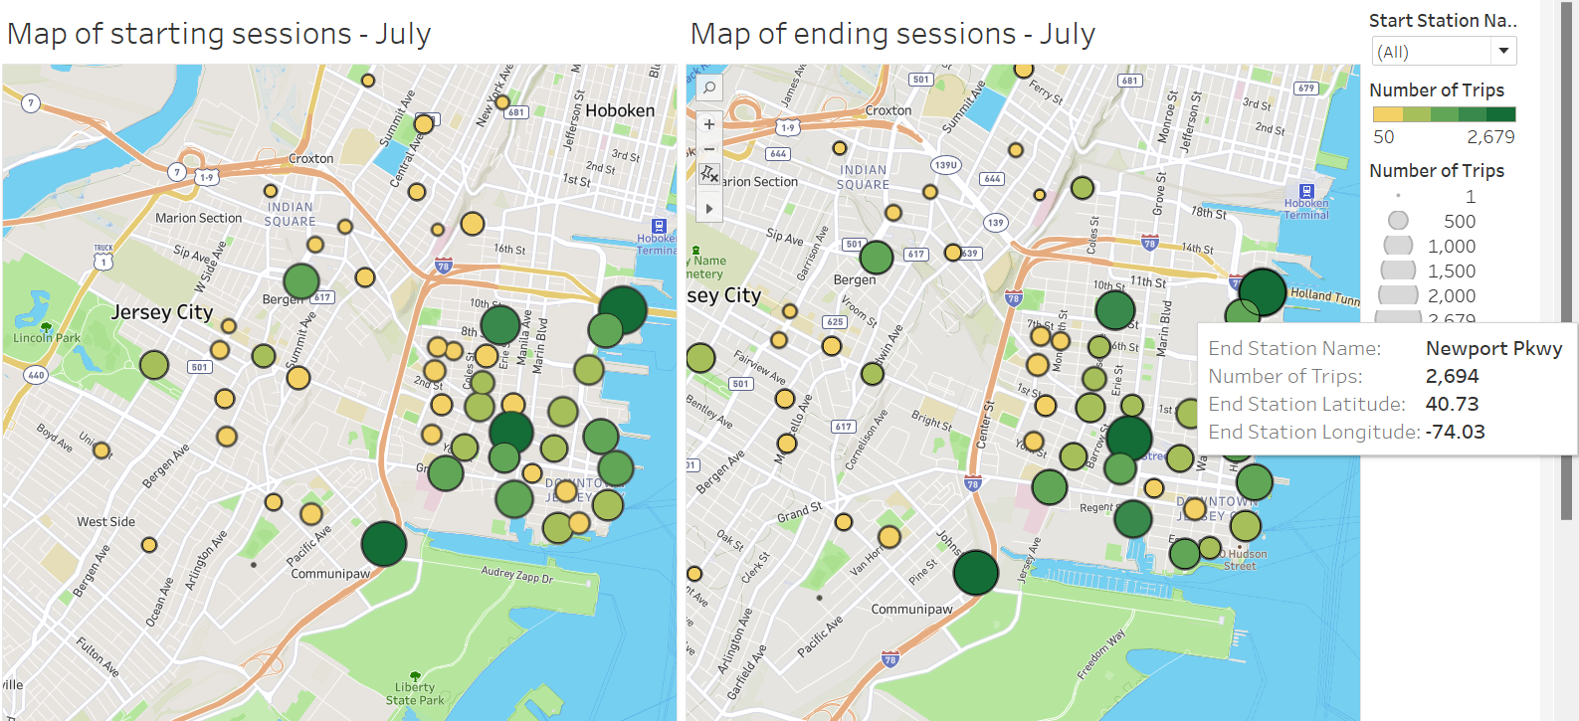

Figure 2. Popularity of Stations in July

As shown in the Figure 3 the profile of the average user didn’t change over the months. The bikes are most popular within males aged between 31 and 40. However, in January the interest within other age groups and genders was significantly lower. This changed in July as the overall interest grew across all groups, especially 51 to 60 years old both males and females and females aged 21 to 30.

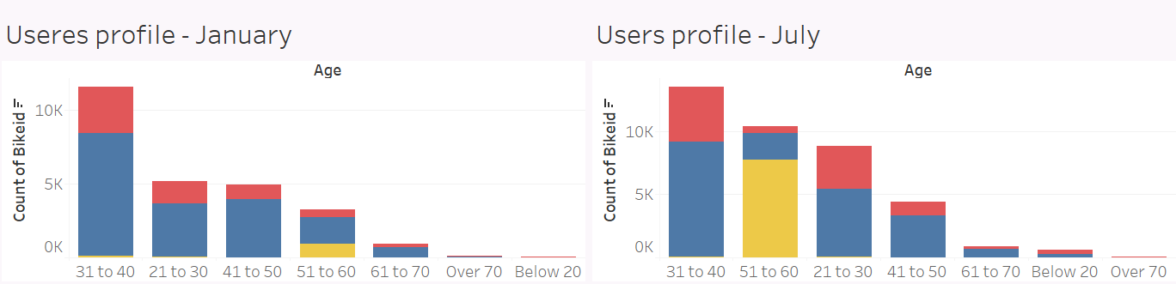

Figure 3. Users profile

Similarly, the average trip duration increased in the summer month. In winter the longest bike trips were performed by users aged 51 to 60 and on average the tip lasted around 10 minutes. In July, females aged below 20s used the bikes for the longest and overall average trip duration was more than half an hour.

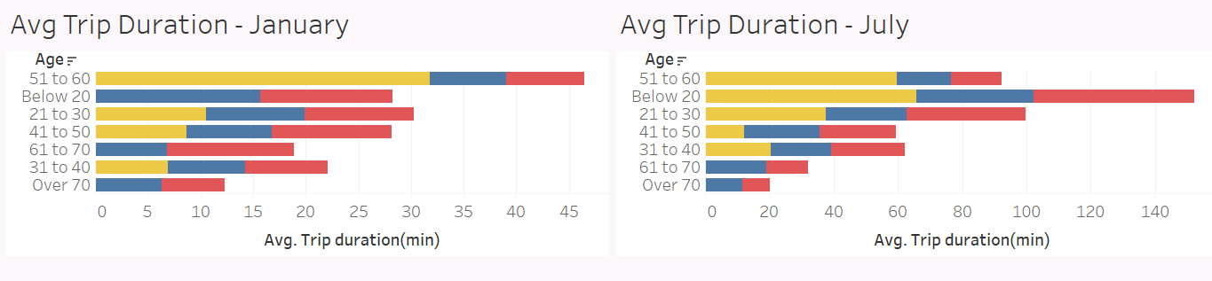

Figure 4. Average Trip Duration

In the wintertime main peak times for bike trips were rush hours - 8am and 5pm, which may be caused by the short daylight period and people using bikes mostly for commuting to work. In the summer, interest grew in the afternoons. The main peak for rental was 6pm. The increase of the average trip duration indicated a shift to more recreational use. This may be caused by warmer weather and longer daylight.

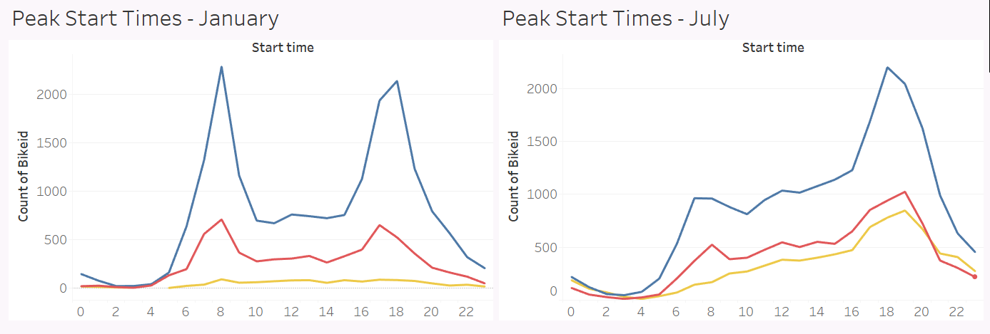

Figure 5. Peak Start Times